BSc (Hons) in Computing

Level C/I/H

 [](http://apiit.edu.my/)

**INDIVIDUAL ASSIGNMENT**

**Module Code & Title: COM40004 - Web Development and Operating Systems-1**

**Prepared By: Kevin Rodrigo [CB011185]**

**Date of Submission: 31st May 2023**

**Instructor: Ms. Dilani**

**Word Count: 1132**

|  |  |  |
| --- | --- | --- |
| **MARKING CRITERIA** | **%** | **MARKS OBTAINED** |
|  |  |  |
|  |  |  |
|  |  |  |
|  |  |  |
|  |  |  |
|  |  |  |
|  |  |  |
| **TOTAL (%)** | |  |

**TABLE OF CONTENTS**

About website 3

Development of Website 4

Low Fidelity Diagrams 6

Desktop UIs 6

Mobile UIs 13

Validation Screenshots 20

Desktop 20

21

22

23

25

Mobile 26

References 29

Figure 1: Home Page (DESKTOP UIs) 6

Figure 2: Turtle Categories page (DESKTOP UIs) 7

Figure 3:Hikkaduwa Turtle Hatchery page (DESKTOP UIs) 8

Figure 4:Threats to Turtles (DESKTOP UIs) 9

Figure 5: Kosgoda Turtle Hatchery (DESKTOP UIs) 10

Figure 6: Bentota turtle hatchery (DESKTOP UIs) 11

Figure 7: Purchase and Donate (DESKTOP UIs) 12

Figure 8: Menu (Mobile UIs) 13

Figure 9: Home Page (Mobile UIs) 14

Figure 10: Turle Categories Page (Mobile UIs) 15

Figure 11: Hikkaduwa Turtle Hatchery (Mobile UIs) 16

Figure 12: Threats of Turtles (Mobile UIs) 17

Figure 13: Kosgoda and Bentota turtle hatchery pages (Mobile UIs) 18

Figure 14: Purchase and Donate (Mobile UIs) 19

Figure 15: Turtle Categories (Web Application) 20

Figure 16: Home Page (Web Application) 20

Figure 17: Hikkaduwa Turtle Hatchery (Web Application) 21

Figure 18: Threats to Turtles (Web Application) 22

Figure 19: Bentota Turtle Hatchery (Web Application) 23

Figure 20: Kosgoda Turtle Hatchery (Web Application) 24

Figure 21: Purchase and Donate (Web Application) 25

Figure 22: Turtle Categories (Mobile Application) 26

Figure 23: Menu (Mobile Application) 26

Figure 24: Home Page (Mobile Application) 26

Figure 25: Hikkaduwa Turtle Hatchery (Mobile Application) 27

Figure 26: Bentota Turtle Hatchery (Mobile Application) 27

Figure 27: Threats to Turtle (Mobile Application) 27

Figure 29: Kosgoda Turtle Hatchery (Mobile Application) 28

Figure 28: Purchase and Donate (Mobile Application) 28

Introduction

### About website

The website "Turtle Hatcheries in Sri Lanka" acts as a comprehensive website for disseminating knowledge and promoting awareness of Sri Lanka's efforts to save turtles. The website strives to inform users about various elements of turtle hatcheries, their importance, and the conservation difficulties these amazing animals confront through its user-friendly interface and quantity of content.

The home page of the website serves as an inviting gateway, capturing the attention of visitors with captivating visuals and engaging content. It provides an overview of the website's mission and objectives, emphasizing the importance of turtle conservation and the critical role played by hatcheries in preserving these endangered species. Through vivid descriptions and stunning imagery, the home page sets the tone for an immersive journey into the world of turtles.

One of the key sections of the website is the "Turtle Categories" page, which offers a comprehensive guide to the different species of turtles found in Sri Lanka. Visitors can explore in detail the various types of turtles that inhabit the region's coastal areas, including the Green Turtle, Olive Ridley Turtle, Loggerhead Turtle, Hawksbill Turtle, and Leatherback Turtle. Each category provides fascinating insights into the physical characteristics, behavior, and nesting habits of these remarkable creatures.

The website also features dedicated pages for specific turtle hatcheries, starting with the "Hikkaduwa Turtle Hatchery" page. Here, visitors can delve into the unique initiatives and conservation efforts undertaken by the Hikkaduwa Turtle Hatchery, which has gained recognition as a pioneering institution in Sri Lanka's conservation landscape. The page highlights the hatchery's achievements, such as rescuing and rehabilitating injured turtles, conducting educational programs, and promoting sustainable tourism practices.

In addition to the Hikkaduwa Turtle Hatchery, the website showcases other renowned turtle hatcheries in Sri Lanka, including Kosgoda and Bentota. Each hatchery has its own dedicated page, offering visitors an in-depth look into their conservation activities, success stories, and the ways in which they contribute to the protection of turtles in the region. By providing comprehensive profiles of these hatcheries, the website aims to encourage visitors to support their work and contribute towards the conservation cause.

The website acknowledges the threats faced by turtles in their natural habitats through its informative "Threats to Turtles" page. It sheds light on various human-induced factors that pose significant risks to these vulnerable creatures, such as habitat destruction, pollution, illegal trade, and climate change. By educating visitors about these challenges, the website aims to inspire action and promote responsible behaviors that can help mitigate the threats and protect the future of turtles.

Furthermore, the website offers a dedicated "Purchase and Donate" page, providing an opportunity for visitors to contribute directly to the conservation efforts. Through this page, users can explore options to support turtle hatcheries by purchasing merchandise, making donations, or even participating in volunteer programs. This section aims to foster a sense of community engagement and empower visitors to become active participants in the conservation movement.

In conclusion, the "Turtle Hatcheries in Sri Lanka" website stands as a valuable resource for individuals interested in turtle conservation and the remarkable work carried out by hatcheries in Sri Lanka. Through its comprehensive pages, the website offers a wealth of information, inspiring visitors to appreciate the importance of turtle conservation, learn about the different species, understand the threats they face, and contribute towards their preservation. By raising awareness and promoting engagement, this website plays a crucial role in safeguarding the future of turtles in Sri Lanka.

### Development of Website

The website "Turtle Hatcheries in Sri Lanka" has been developed using HTML and CSS, focusing on creating an engaging user experience through animations. The use of animations enhances the visual appeal and interactivity of the website.

On the website's pages, animations are implemented to enhance the user's first impression. Upon loading the page, users are greeted with captivating animations that grab their attention and create a visually appealing experience. These animations can include subtle transitions, fade-ins, or movements that bring elements of the page to life.

Additionally, hover animations are utilized throughout the website to provide an interactive experience for users. When users hover their cursor over interactive elements such as buttons or links, animations are triggered to provide visual feedback and engage the user's attention. These animations can be simple effects like color changes, underline movements, or image enlargements, creating a responsive and interactive environment.

By incorporating animations on load and hover, the website becomes more dynamic and immersive. It adds an element of delight and surprise, making the browsing experience more enjoyable for visitors. These animations also help guide users' attention to important information, calls to action, or navigation options, improving the overall usability of the website.

The use of HTML and CSS allows for the creation of these animations without relying on external libraries or complex scripting languages. Through well-structured CSS code and keyframe animations, the website achieves smooth and visually appealing effects that enhance the overall user experience.

In conclusion, the "Turtle Hatcheries in Sri Lanka" website employs animations on load and hover to create a captivating and interactive user experience. Through the use of HTML and CSS, the website incorporates subtle animations that engage users from the moment they load the page and provide responsive feedback when interacting with elements on the site. These animations enhance the visual appeal, usability, and overall enjoyment of exploring the content and resources related to turtle conservation in Sri Lanka.

## Low Fidelity Diagrams

### Desktop UIs

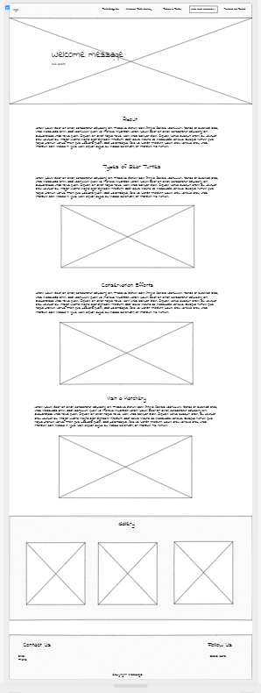

Figure 1: Home Page (DESKTOP UIs)

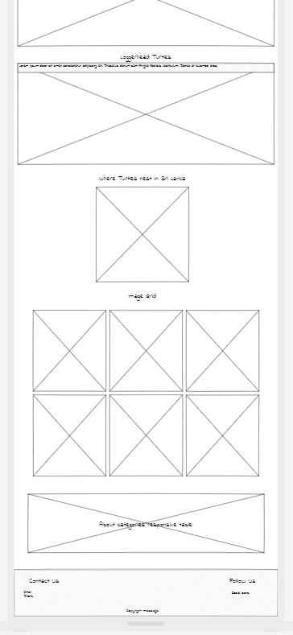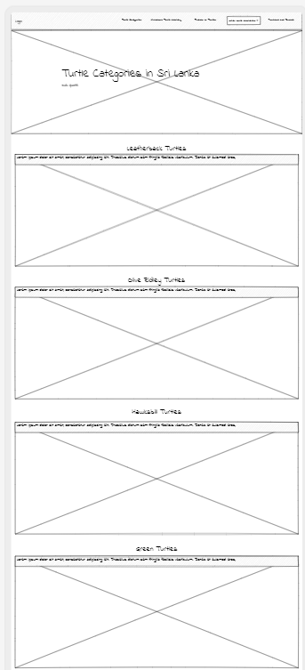

Figure 2: Turtle Categories page (DESKTOP UIs)

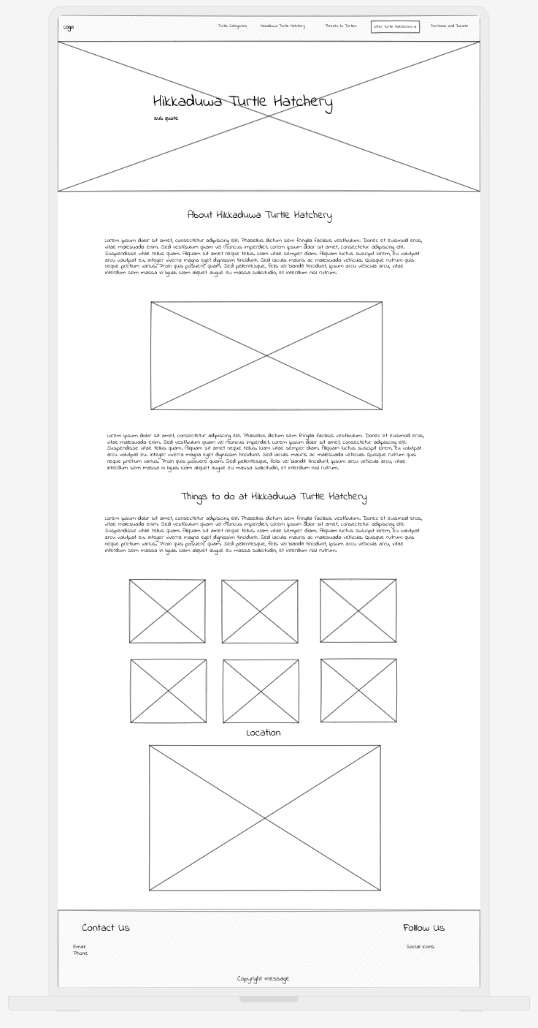

Figure 3:Hikkaduwa Turtle Hatchery page (DESKTOP UIs)

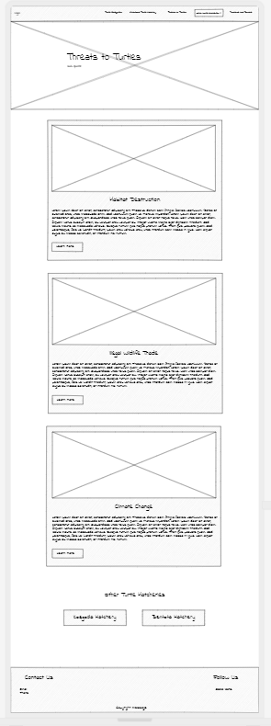

Figure 4:Threats to Turtles (DESKTOP UIs)

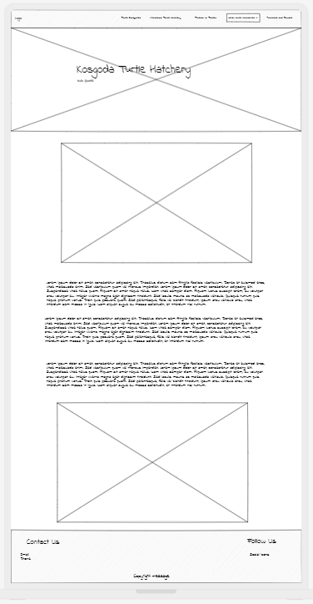

Figure 5: Kosgoda Turtle Hatchery (DESKTOP UIs)

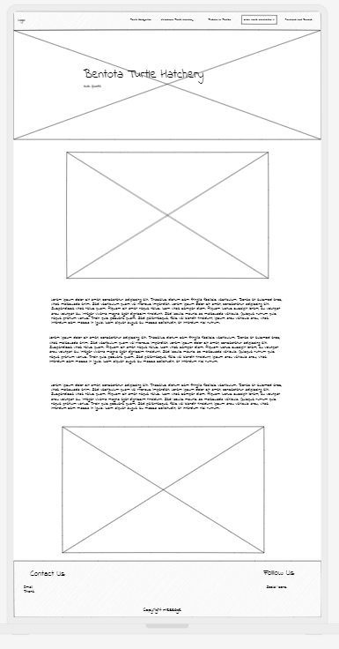

Figure 6: Bentota turtle hatchery (DESKTOP UIs)

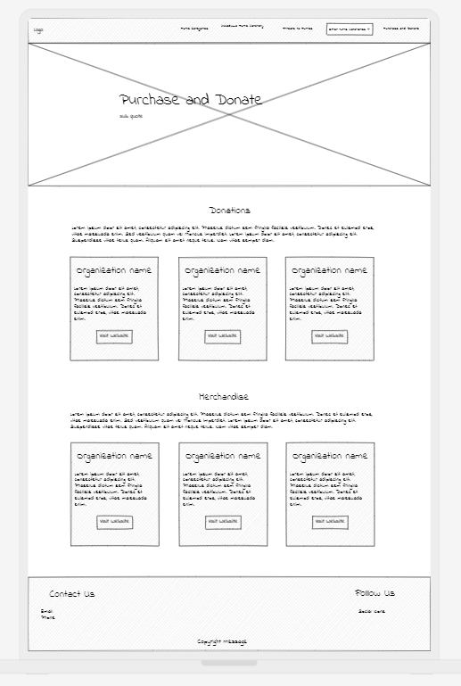

Figure 7: Purchase and Donate (DESKTOP UIs)

### Mobile UIs

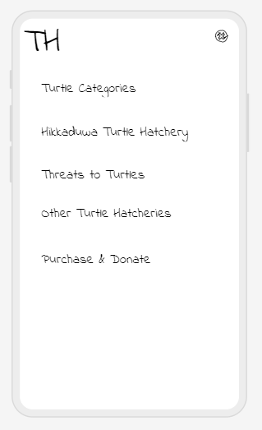

Figure 8: Menu (Mobile UIs)

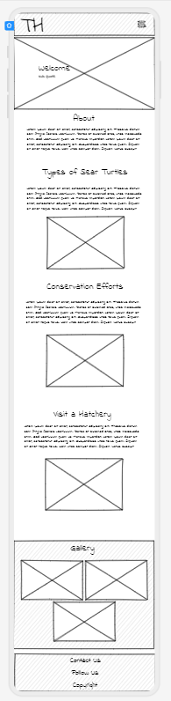

Figure 9: Home Page (Mobile UIs)

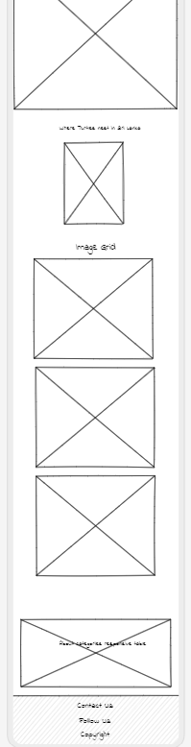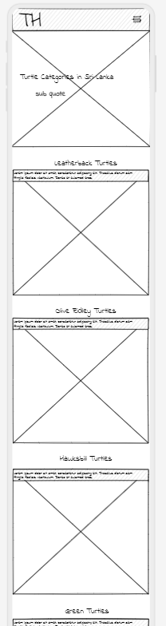

Figure 10: Turle Categories Page (Mobile UIs)

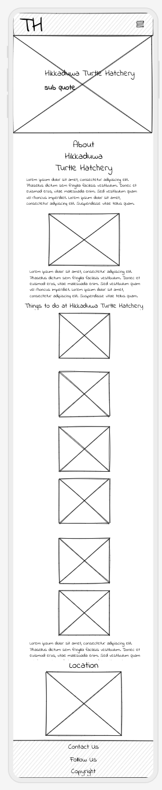

Figure 11: Hikkaduwa Turtle Hatchery (Mobile UIs)

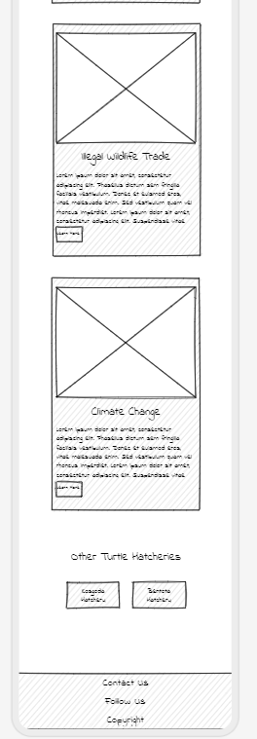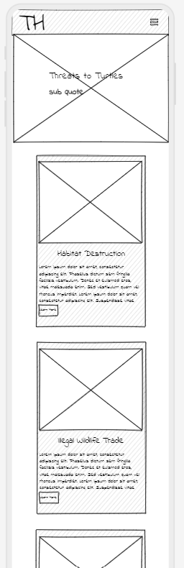

Figure 12: Threats of Turtles (Mobile UIs)

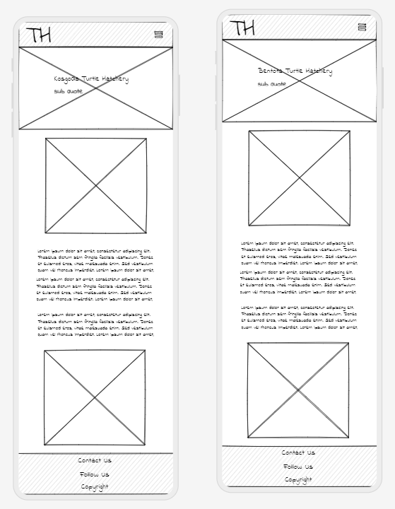

Figure 13: Kosgoda and Bentota turtle hatchery pages (Mobile UIs)

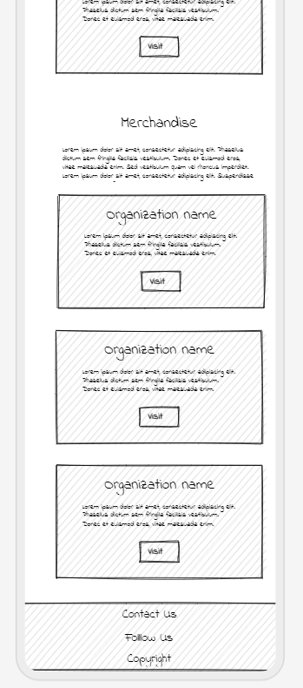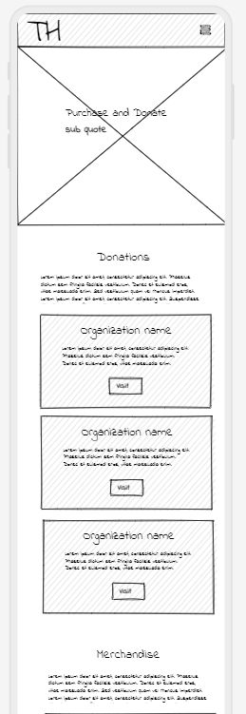

Figure 14: Purchase and Donate (Mobile UIs)

## Validation Screenshots

## Desktop

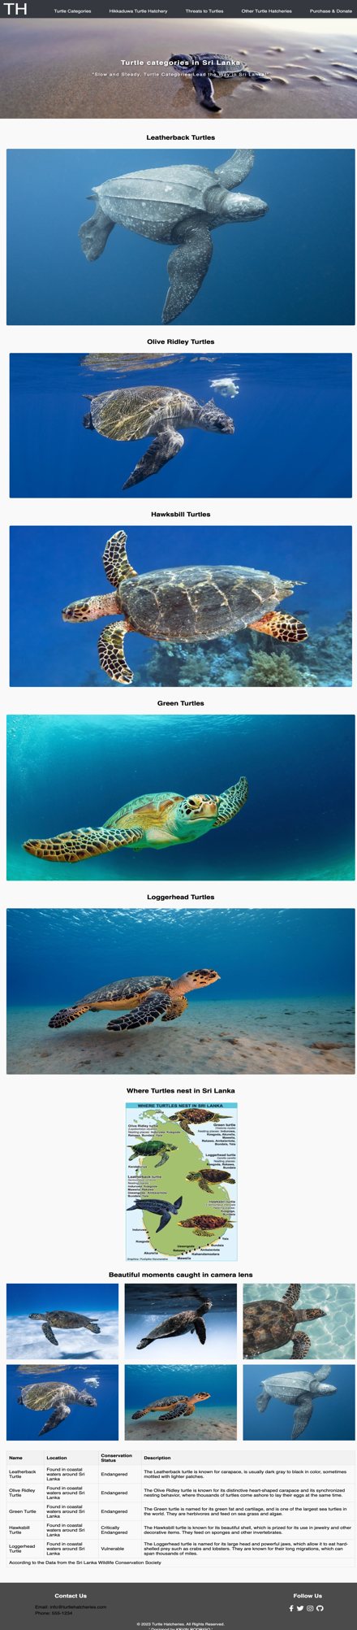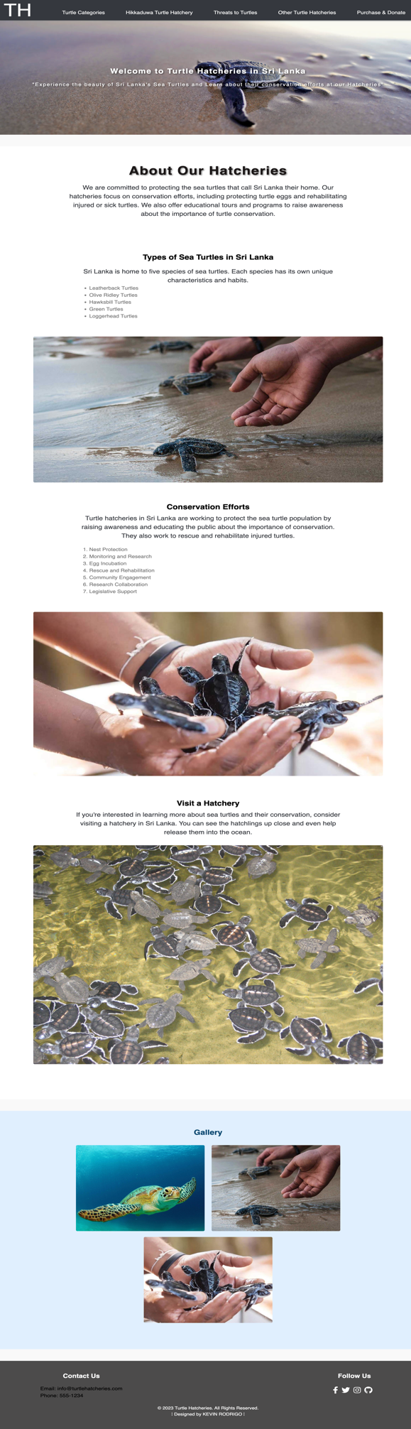

Figure 15: Turtle Categories (Web Application)

Figure 16: Home Page (Web Application)

## 

Figure 17: Hikkaduwa Turtle Hatchery (Web Application)

## 

Figure 18: Threats to Turtles (Web Application)

## 

Figure 19: Bentota Turtle Hatchery (Web Application)

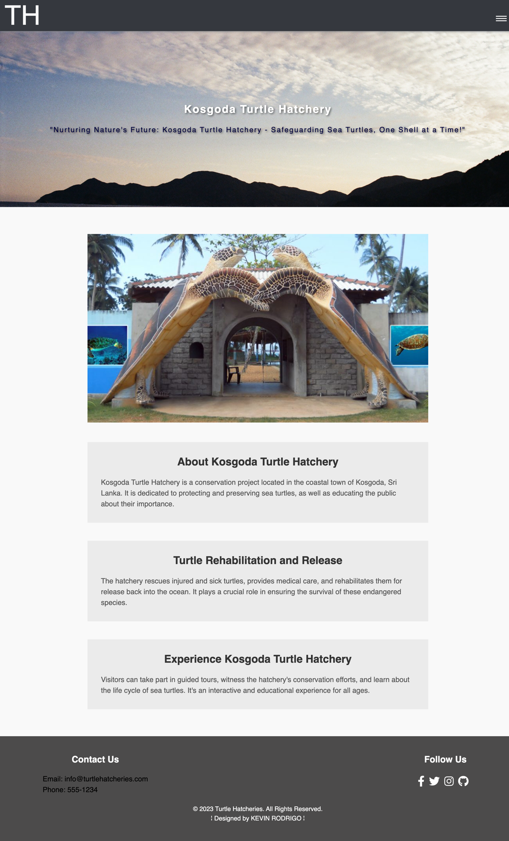

Figure 20: Kosgoda Turtle Hatchery (Web Application)

## 

Figure 21: Purchase and Donate (Web Application)

## A close-up of a person's hands Description automatically generated with medium confidenceA close-up of a person's hands Description automatically generated with medium confidenceMobile

Figure 22: Turtle Categories (Mobile Application)

Figure 23: Menu (Mobile Application)

Figure 24: Home Page (Mobile Application)

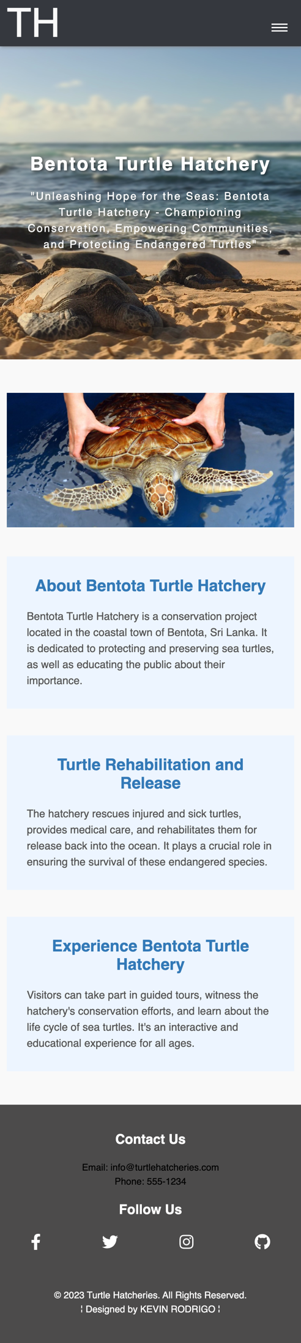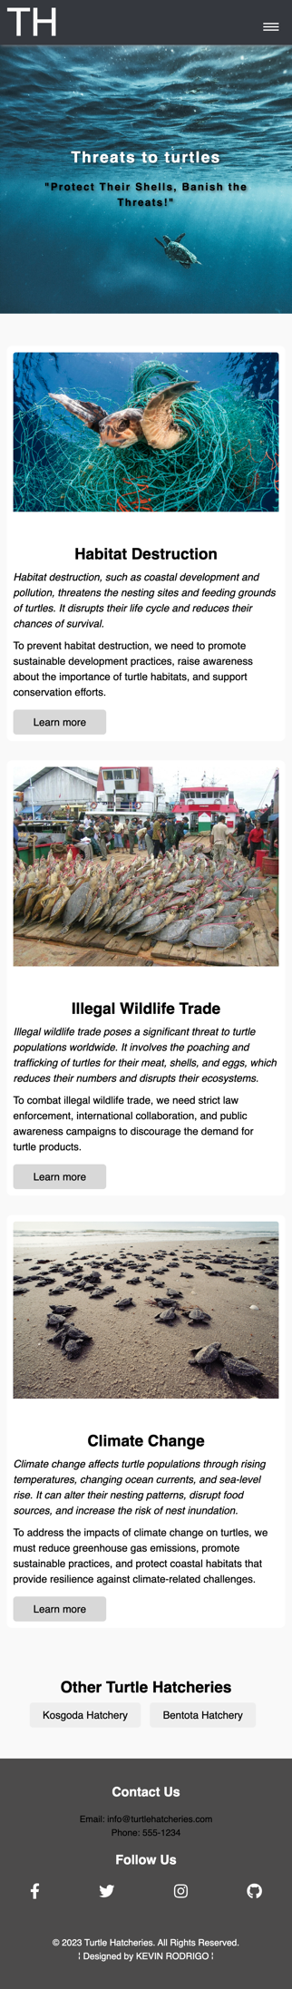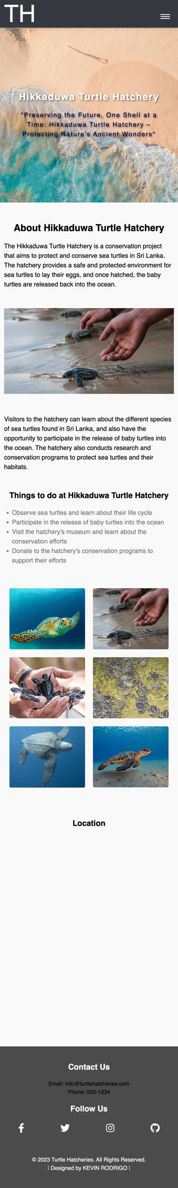

Figure 25: Hikkaduwa Turtle Hatchery (Mobile Application)

Figure 26: Bentota Turtle Hatchery (Mobile Application)

Figure 27: Threats to Turtle (Mobile Application)

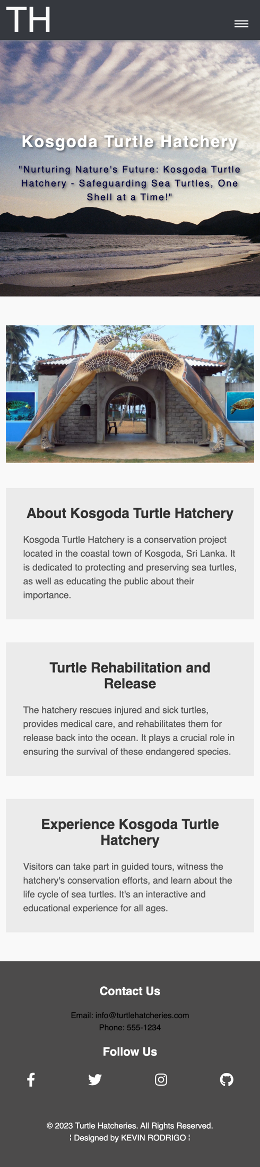

Figure 29: Kosgoda Turtle Hatchery (Mobile Application)

Figure 28: Purchase and Donate (Mobile Application)

## References

The use of images on this website is based solely on sourcing them from open-source, copyright-free platforms like Unsplash, Pixabay, and Pexels, among others. By exclusively relying on these platforms, the website ensures that all images are obtained with proper permissions.

To maintain transparency and acknowledge the origins of the visuals, the website includes a footer in the code that references the sources of the contents. Additionally, the website adheres to the Harvard referencing style in the referencing section, ensuring appropriate citation of any textual content or references used.

By following this approach of using copyright-free images and providing proper attribution, the website respects intellectual property rights and avoids any potential legal issues associated with copyright infringement.